LINUX BASIC COMMANDS

1. ls - is a list information about the FILEs (the current directory by default)

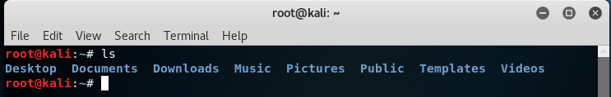

Some of ls command options:

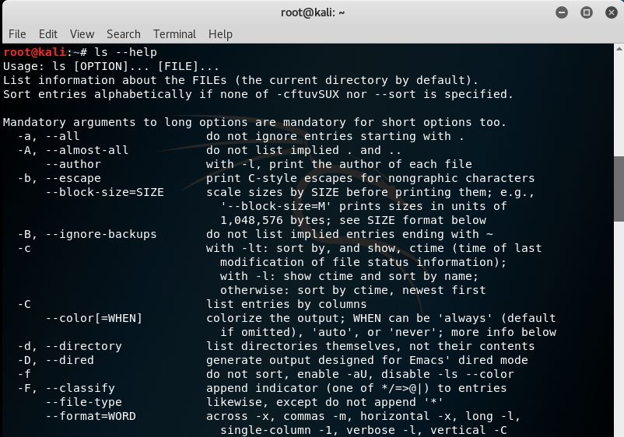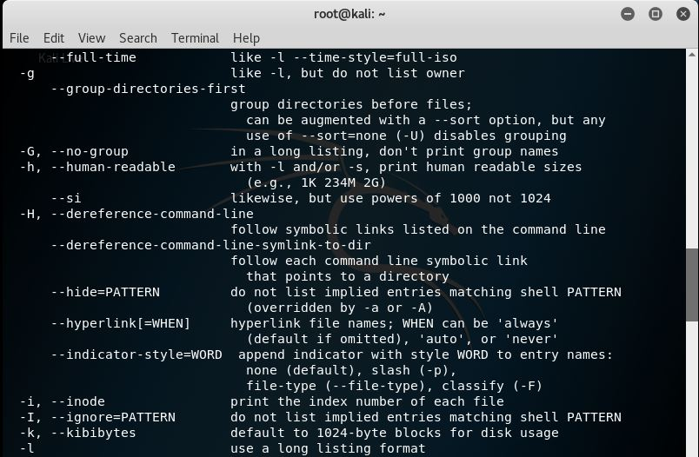

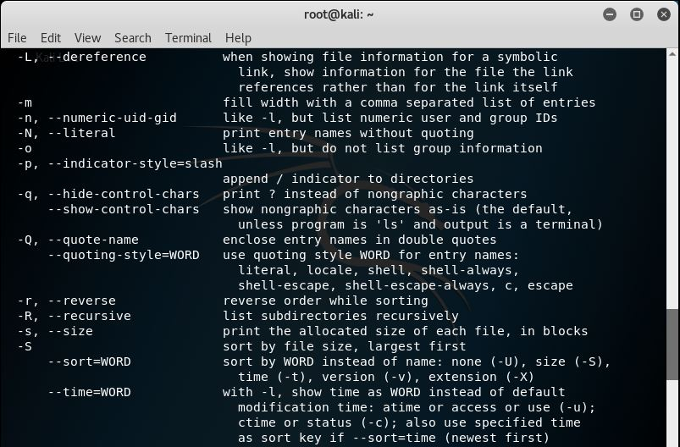

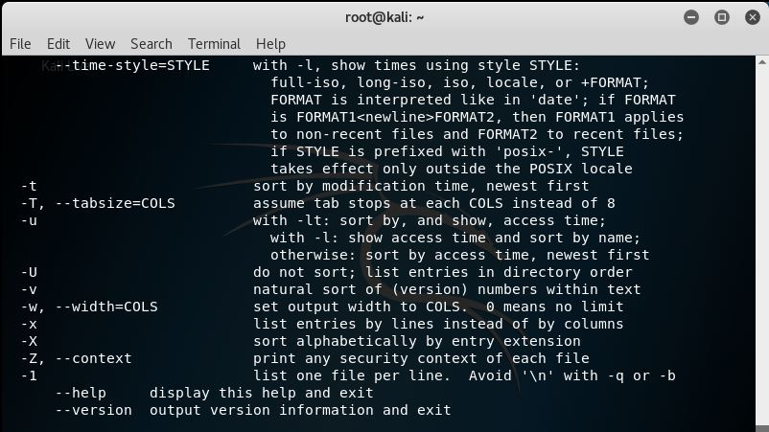

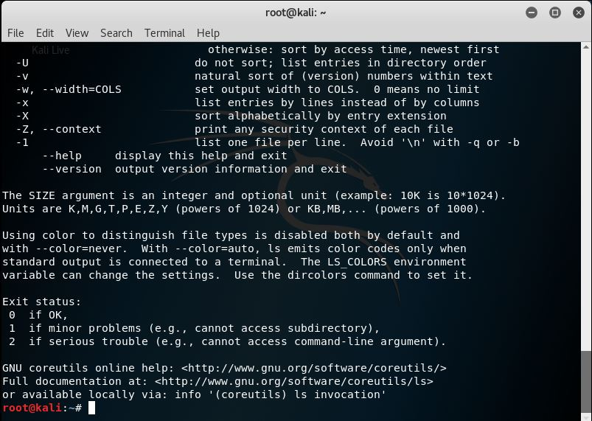

1. cd – change the shell working directory and also change the current directory to DIR.

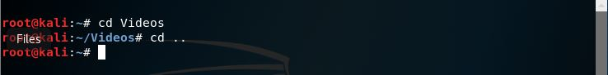

Some of cd command options:

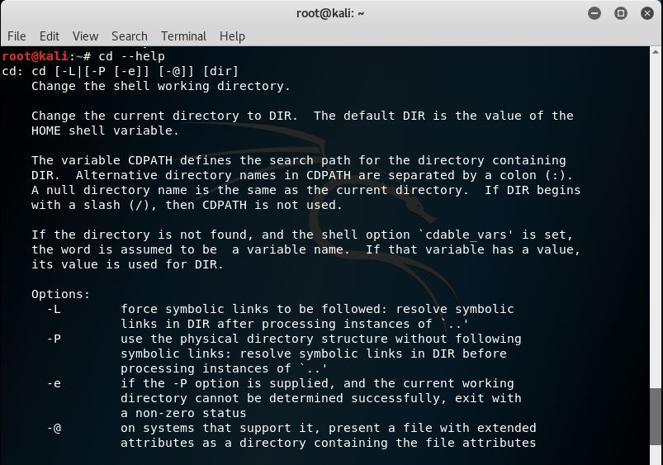

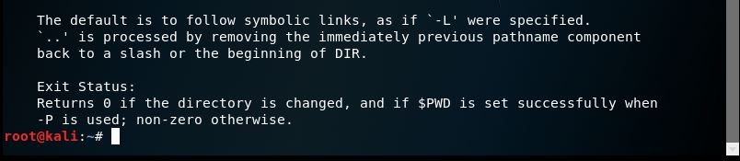

1. mv – rename the SOURCE to DEST, or move SOURCE(s) to DIRECTORY

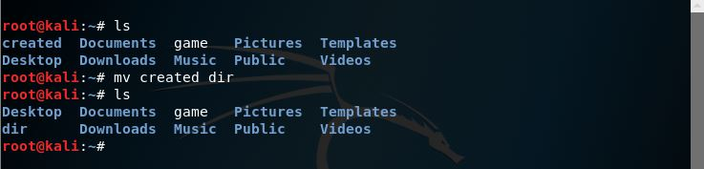

Some of mv command options:

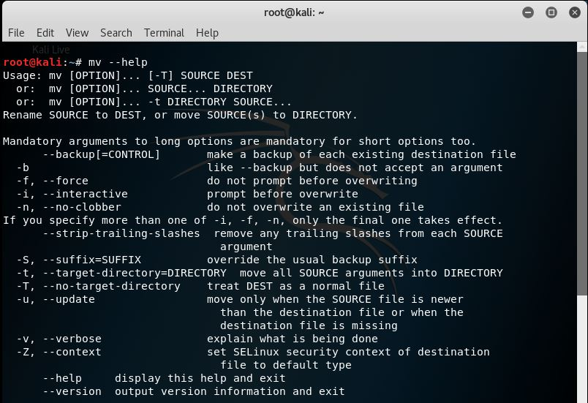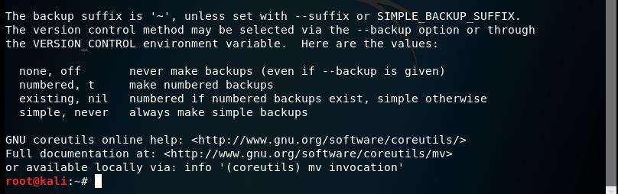

1. cat – concatenate FILE(s) to standard output

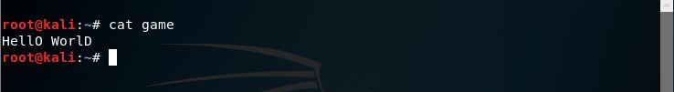

Some of cat command options:

1. cat “file name” – display file
2. cat > “filename” – create file and add data
3. cat >> “filename” – add data to existing file

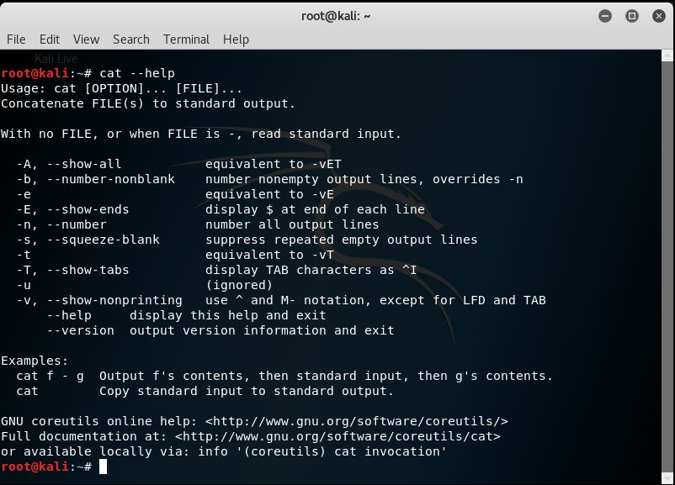

1. rm – remove (unlink) the FILE(s)

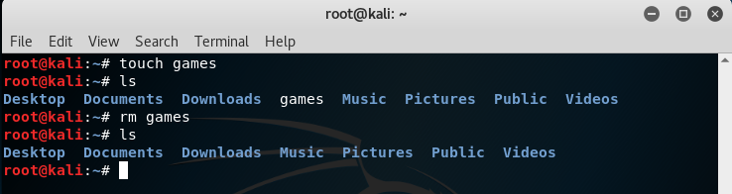

Some of rm command options:

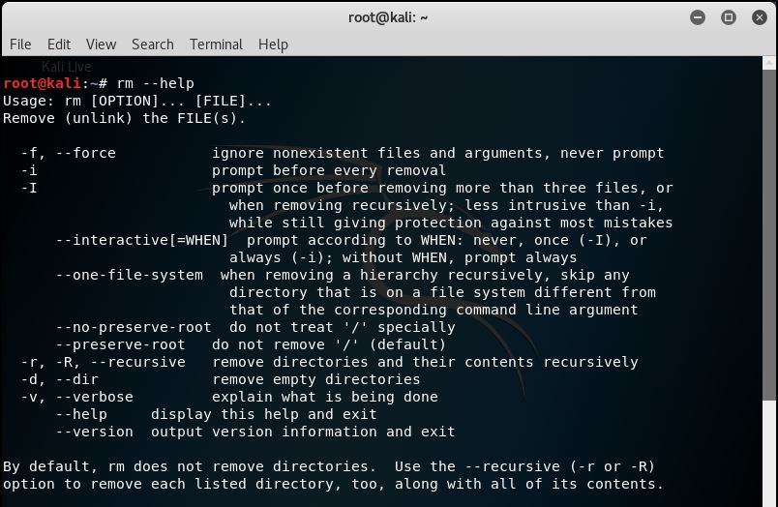

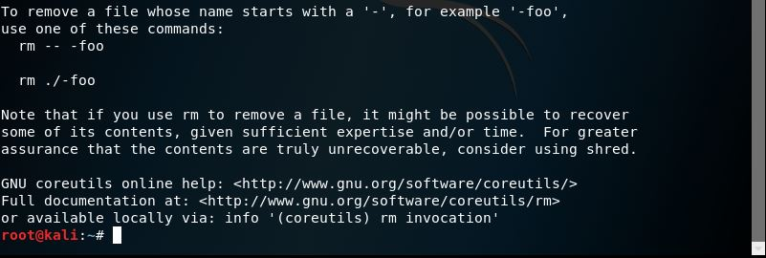

1. mkdir/rmdir

mkdir – create the DIRECTORY(ies), if they do not already exist.

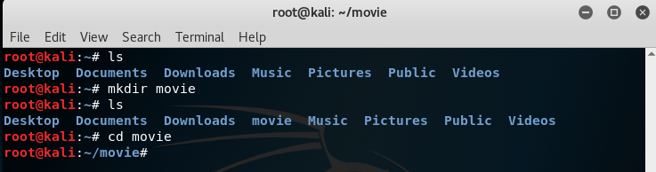

rmdir - remove the DIRECTORY(ies), if they empty.

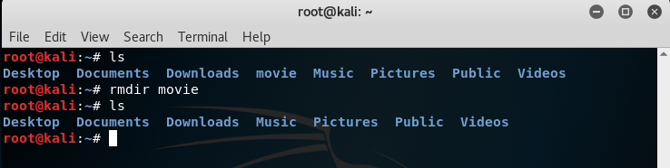

Some of mkdir/rmdir command options:

* mkdir :

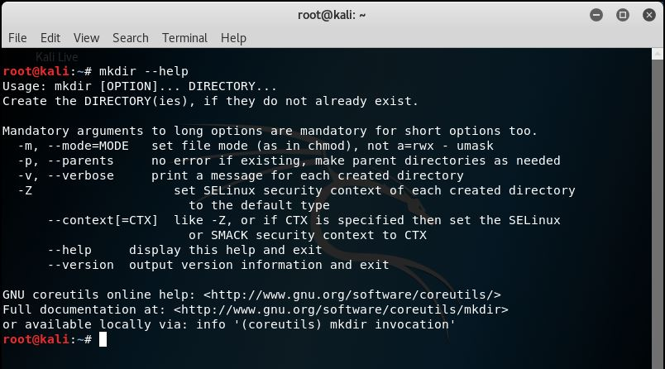

* rmdir :

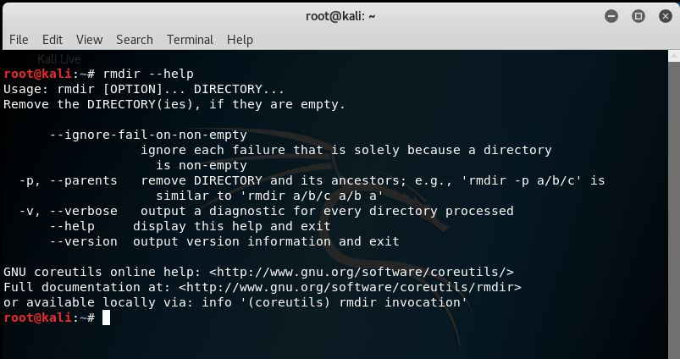

1. touch – update the access and modification times of each FILE to the current time.

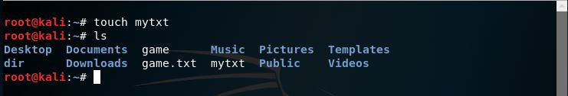

Some of touch command options:

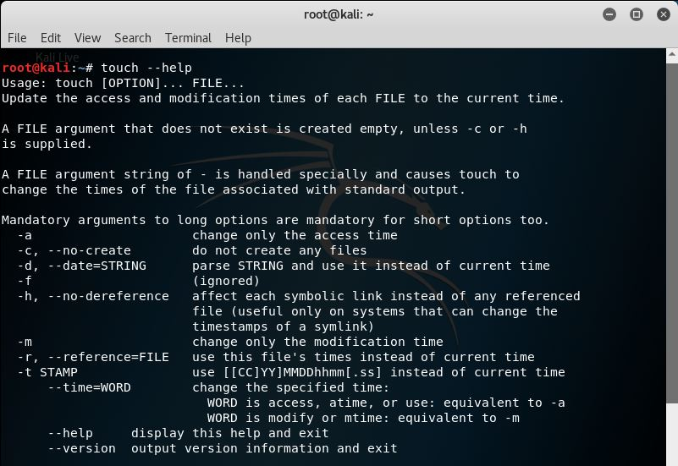

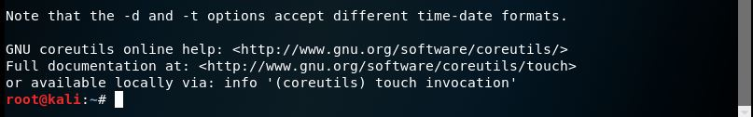

1. pwd – print the name of the current working directory.

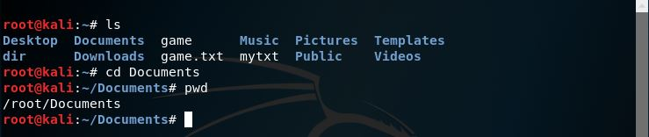

Some of pwd command options:

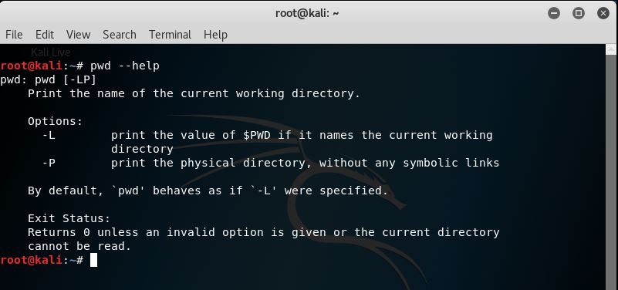

1. top - (table of processes) is a task manager program for Unix like other operating systems. It produces an ordered list of running processes selected by user-specified criteria.

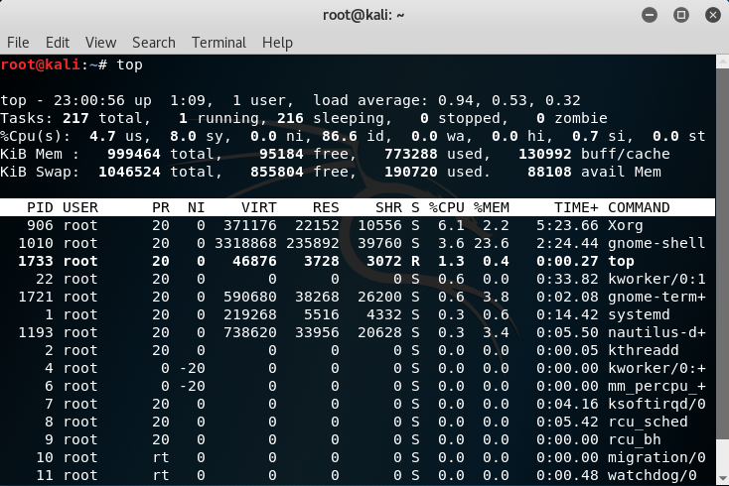

1. ps - (process status) displays the currently-running processes.

* PID = Process ID number
* TTY = Terminal associated with the process
* CMD = Name of the process, including arguments.

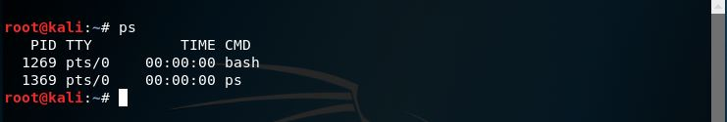

1. Kill – send the processes identified by PID or JOBSPEC the signal named by SIGSPEC or SIGNUM. If neither SIGSPEC nor SIGNUM is present, then SIGTERM is assumed.

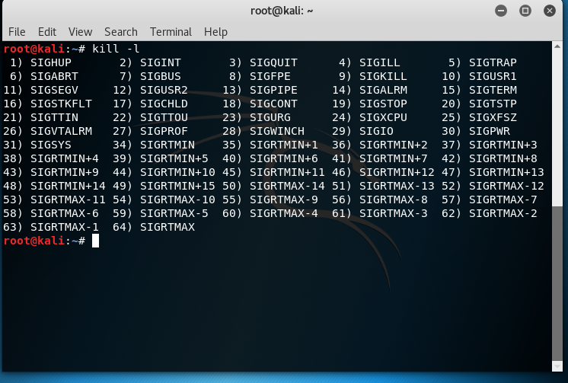

Some of kill command options:

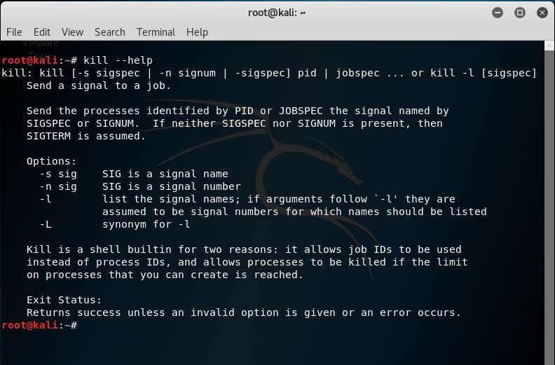

1. wc – (word count) is a command for print newline, word and byte counts for each FILE,and a total line if more than one FILE is specified.

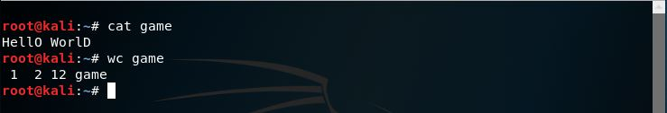

Some of wc command options:

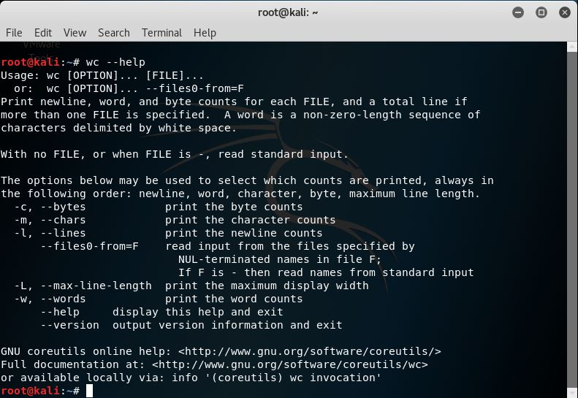

1. grep – search for PATTERN in each FILE.

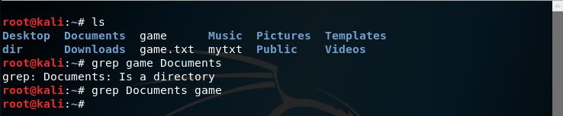

Some of grep command options:

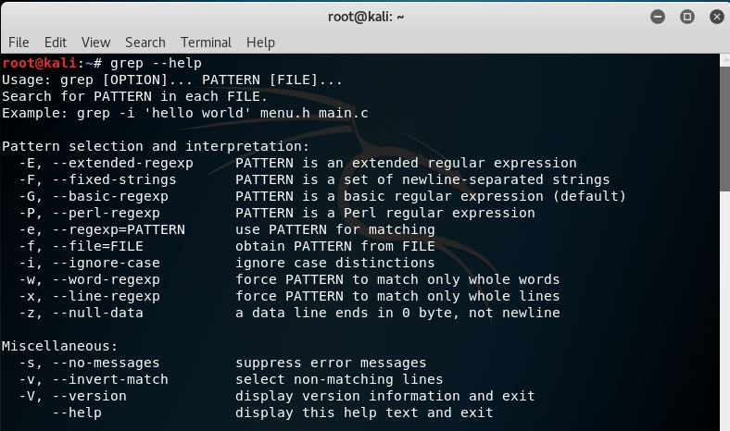

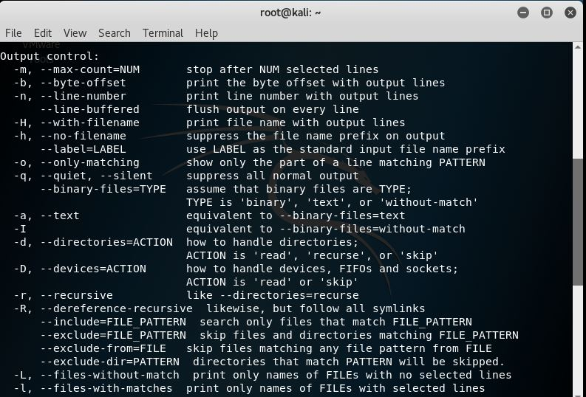

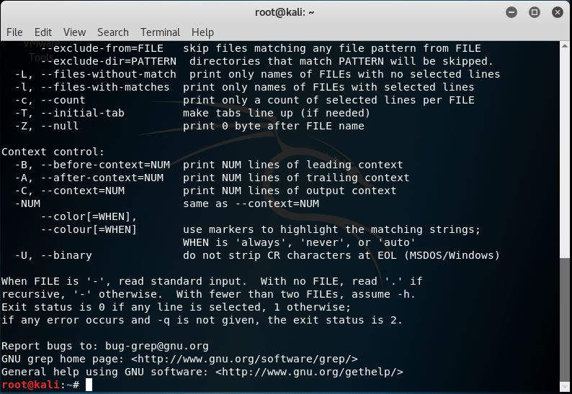

1. more/less

more - is a command to view (but not modify) the contents of a text file.

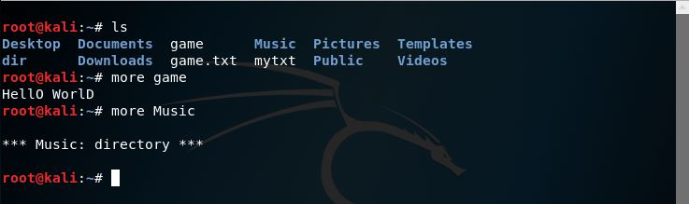

less - to view (but not change) the contents of a text file one screen at a time.

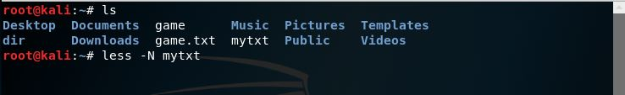

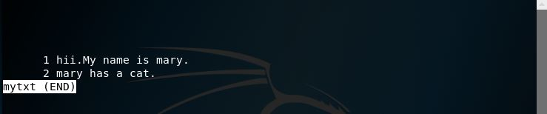

Some of more / less command options:

* more

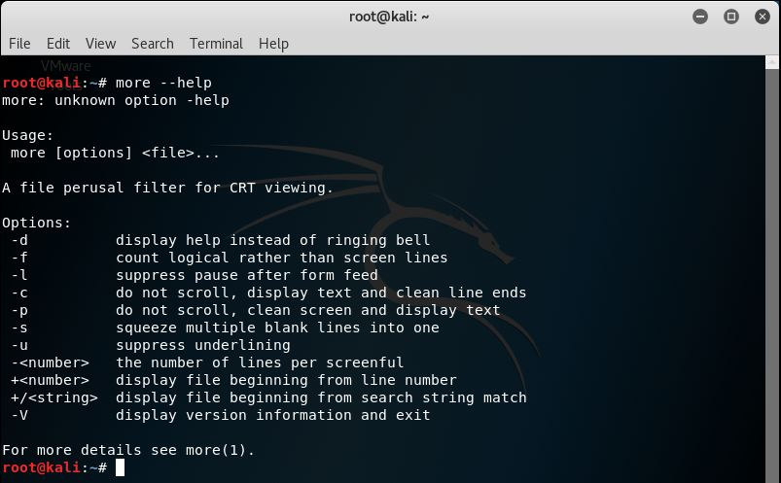

* less

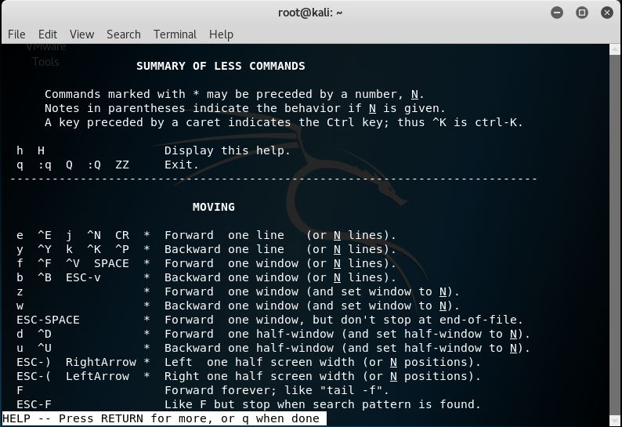

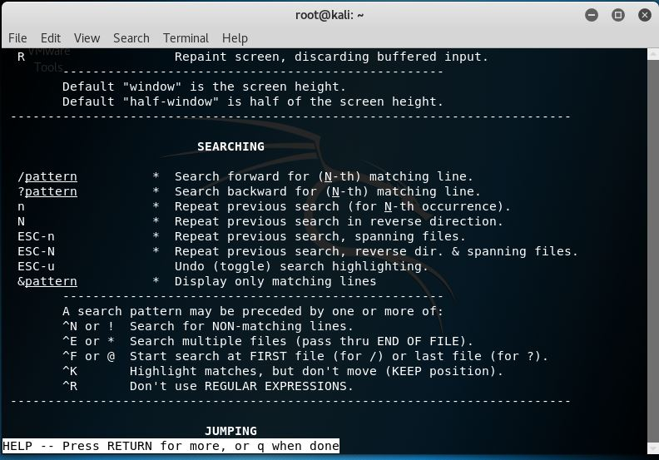

1. file - The command is to determine type of file for example single file, multiple file, viewing mime type and compressed file.

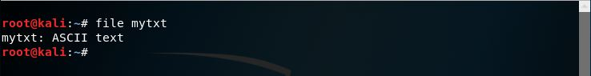

Some of file command options:

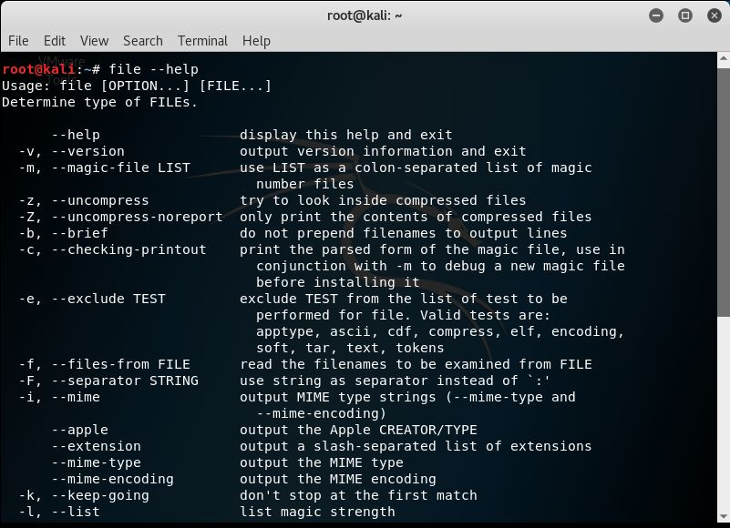

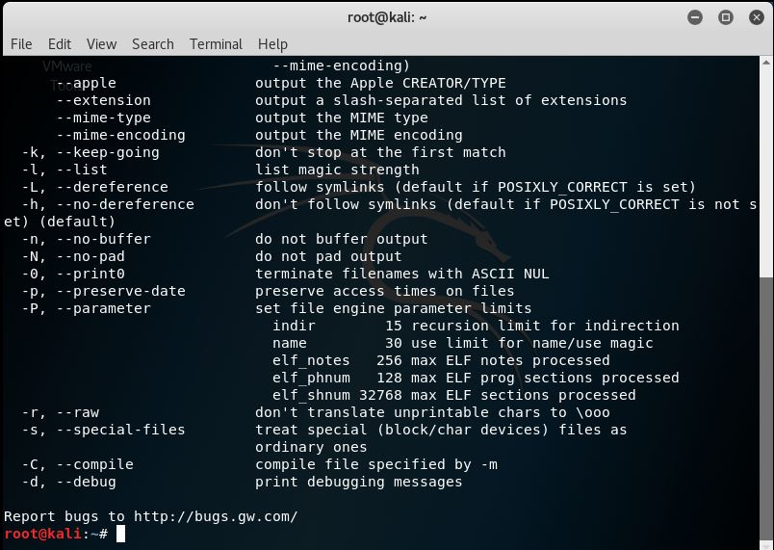

1. ln – is a command to create hard links by default or a symbolic link (symlink) to an existing file.

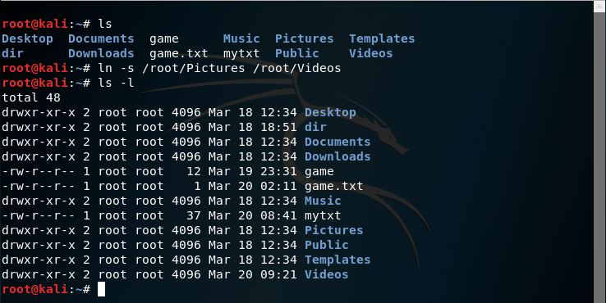

Some of ln command options:

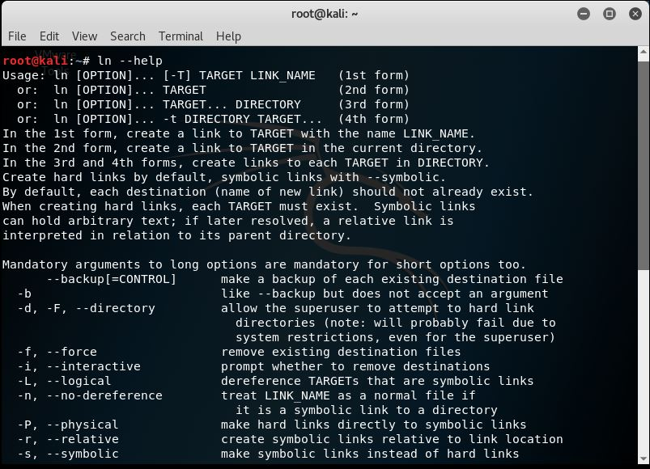

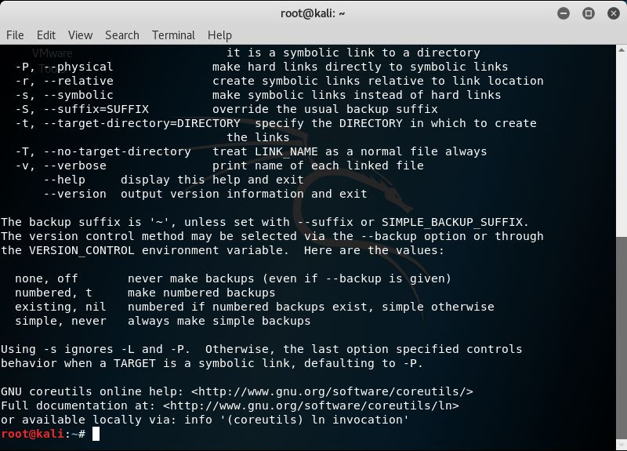

1. uptime – to display the time since the last boot.

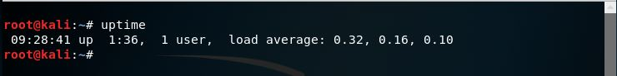

Some of uptime command options:

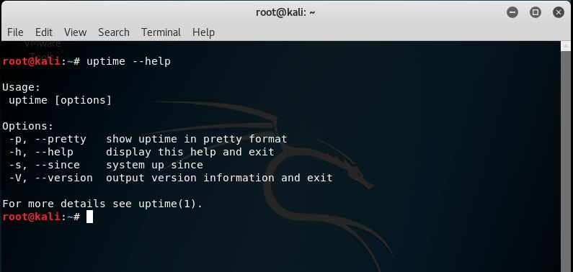

1. unname – print certain system information.

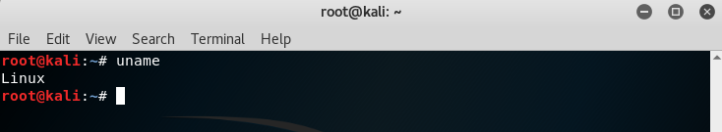

Some of uptime command options:

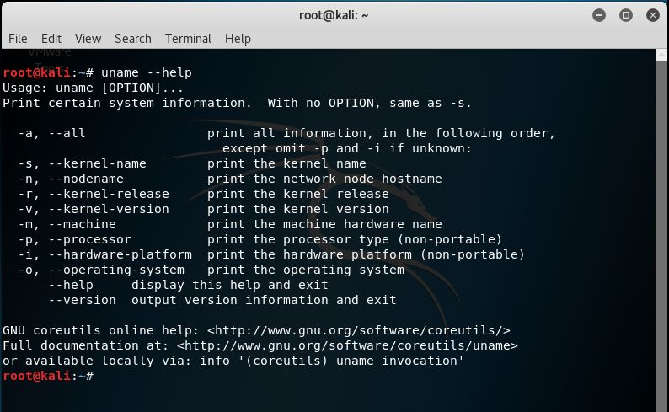

1. chmod/chown

chmod – change the mode of each FILE to MODE.

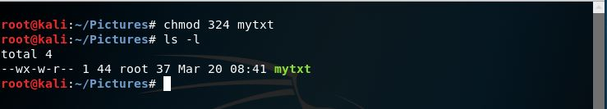

Chown – change the owner and/or change the group of each FILE to OWNER and/or GROUP.

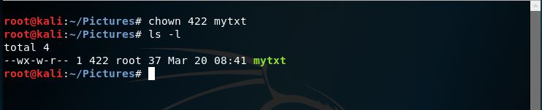

Some of chmod/chown command options:

* chmod :

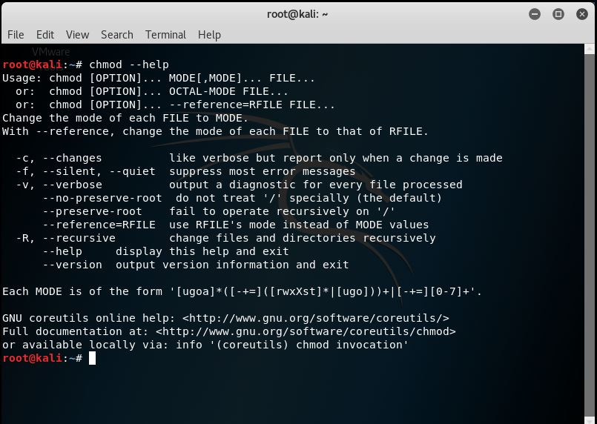

* chown :

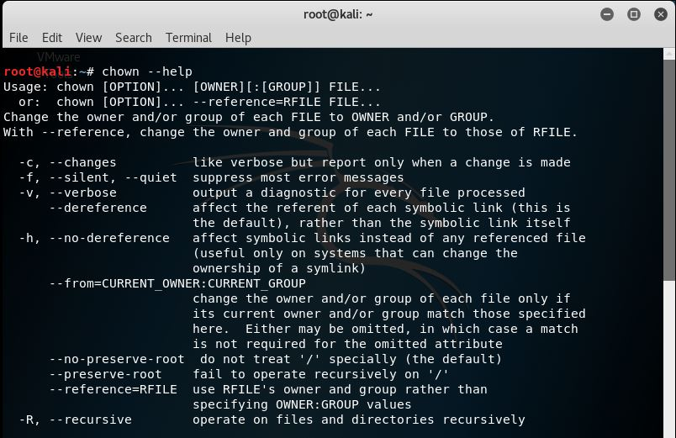

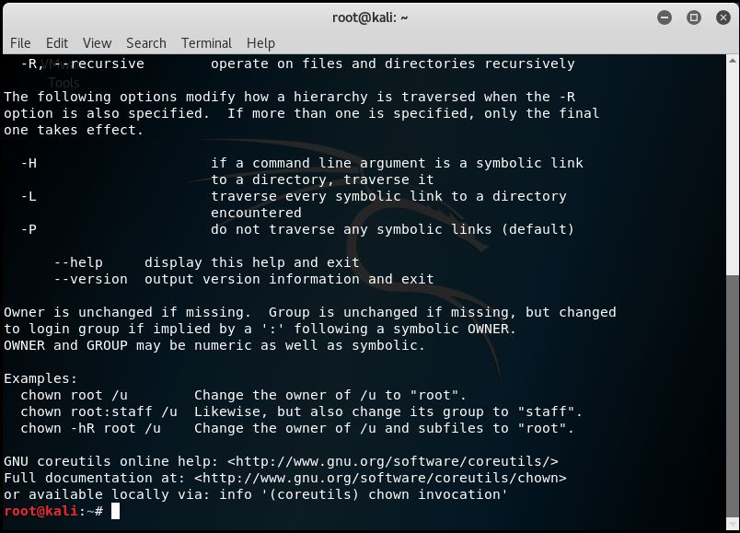

1. ping - to test the reachability of a host on an Internet Protocol (IP) network.

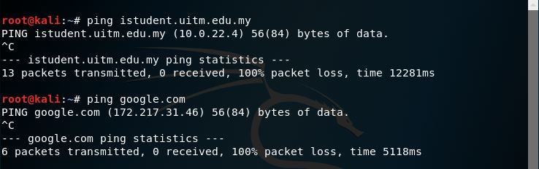

1. netstat - (network statistics) is a command-line that displays network connections for the Transmission Control Protocol, routing tables, and a number of network interface and network protocol statistics.

